

**WEB COURSE**

CP : 1



Name : M. Ahmed

Roll No: 21F-9295

Section : 6-E

Task : 1

 <h1 style="text-align: center;">Introduction </h1>

        <div style="padding:5% 25%;">

   <h2>Name : <span style="font-weight: 400;"> M.Ahmed </span></h2>

   <h2>RollNo : <span style="font-weight: 400;">21F-9295</span></h2>

   <h2>About : <span style="font-weight: 200;"> My name is Ahmed Mussadiq . I'm student of computer science in Fast National University . I had done my inter from Punjab College </span> </h2>

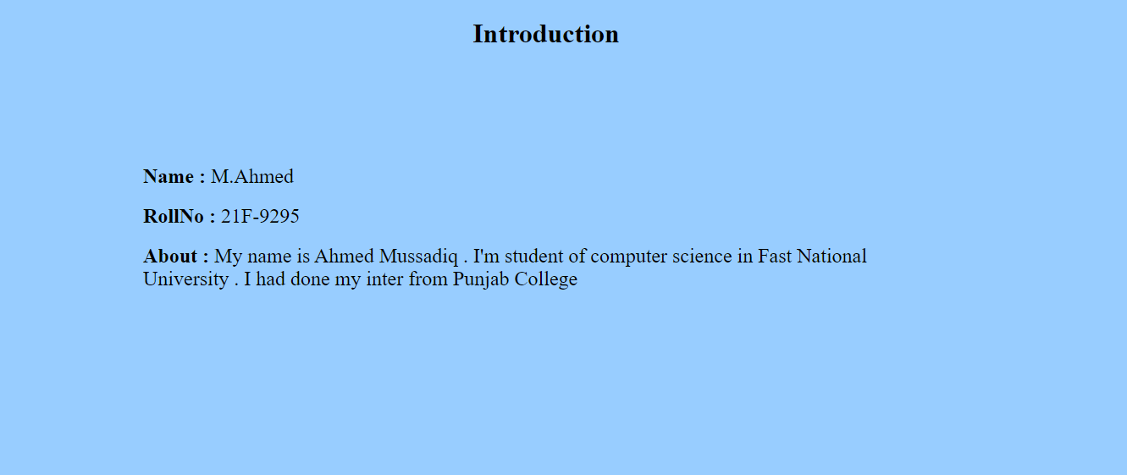

Task : 2

<h1 style="padding-top: 4%;"></h1>

   <b> The Text is Bold </b><br></br>

    <strong> The Text is Strong </strong><br></br>

    <bi>The Text is Big</bi><br></br>

    <i> The Text is Italic </i><br></br>

    <em> The Text is Emphasized  </em><br></br>

    <samp>This is computer output</samp>

  <p>This is<sub>subscript</sub> and

    <sup>superscript</sup><br></br> </p>

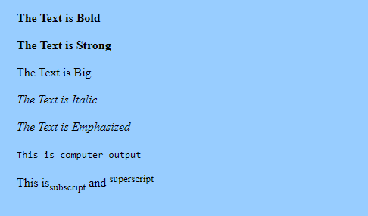

Task : 3

<img  src="fastlogo.png" width="500px" height="500px" style="padding-top: 20%;" alt="">



Task : 4

<a href="https://cfd.nu.edu.pk/"><img  src="fastlogo.png" width="500px" height="500px" style="padding-top: 20%;" alt="">

</a>



Task : 5

<h1>Unordered List</h1>

    <p>We have books on a variety of language</p>

    <ul>

    <li>Oracle</li>

    <li>Java</li>

    <li>HTML</li>

    <li>CSS</li>

    </ul>

    <h1>Follow these steps to install Java</h1>

    <ol type="1">

    <li>DOWNLOAD Software</li>

    <li>EXTRACT Folder</li>

    <li>Execute to run</li>

    </ol>

Task : 6

  <table border="1">

        <tr>

            <th rowspan="3">APRIL</th>

            <td>table</td>

            <td>table</td>

        </tr>

        <tr>

            <td>table</td>

            <td>table</td>

        </tr>

        <tr>

            <td>table</td>

            <td>table</td>

        </tr>

        <tr>

            <td>table</td>

            <td>table</td>

            <td>table</td>

        </tr>

    </table>

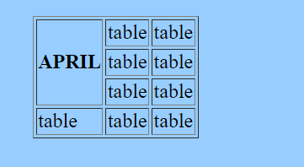

Task : 7

 <table border="1">

        <tr>

            <td>2022</td>

        </tr>

        <tr>

           <th rowspan="2"> <center>FIESTA</center></th>

            <td>table</td>

        </tr>

        <tr>

            <td>table</td>

        </tr>

        <tr>

            <td>table</td>

            <td>table</td>

            <td>table</td>

        </tr>

        <tr>

            <td>table</td>

            <td>table</td>

            <td>table</td>

        </tr>

    </table>

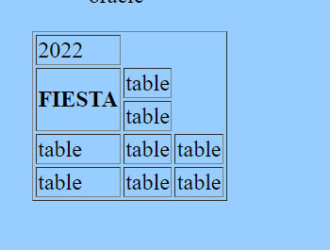

Task : 8

<h1>SIGN UP Page</h1>

<br>

<form action="backend.php"><br>

UserName:

<input type="text" ><br><br>

Email:

<input type="email"><br><br>

Password:

<input type="password"><br><br>

Confirm Password:

<input type="password"><br><br>

<input type="submit" value="submit">

<input type="reset" value="reset">

</form>

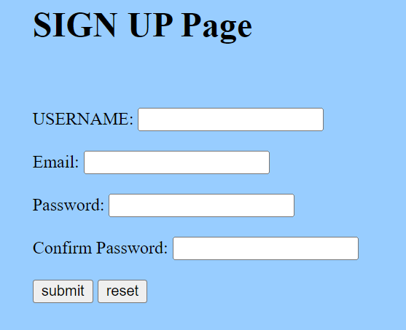

Task : 9

<center><h1>Pete's Pizza Delivery</h1></center>

<center><h2>Online Order Form</h2></center>

<form name="petes_pizza_delivery_online_order_form" type="text/html">

<label for="name">*Name:</label>

<input type="text" id="name" name="name" required><br><br>

<label for="tel">*Tel:</label>

<input type="tel" id="tel" name="tel" required><br><br>

<label for="address">*Address:</label>

<input type="text" id="address" name="address" required><br><br>

<label for="towncity">*Town/city:</label>

<input type="text" id="towncity" name="towncity" required><br><br>

<label for="postcode">*Postcode:</label>

<input type="text" id="postcode" name="postcode" required><br><br>

<label for="email">*Email:</label>

<input type="email" id="email" name="email" required><br><br>

<p><strong>Required fields</strong></p>

<label for="topping">Topping:</label><br>

<input type="radio" id="margherita" name="topping" value="margherita">

<label for="margherita">Margherita</label><br>

<input type="radio" id="meat_feast" name="topping" value="meat_feast">

<label for="meat_feast">Meat Feast</label><br>

<input type="radio" id="four_seasons" name="topping" value="four_seasons">

<label for="four_seasons">Four Seasons</label><br><br>

<label for="size">Size:</label><br>

<input type="radio" id="small" name="size" value="small">

<label for="small">Small</label><br>

<input type="radio" id="medium" name="size" value="medium">

<label for="medium">Medium</label><br>

<input type="radio" id="large" name="size" value="large">

<label for="large">Large</label><br><br>

<label for="extras">Extras:</label><br>

<input type="checkbox" id="mushrooms" name="extras" value="mushrooms">

<label for="mushrooms">Mushrooms</label><br>

<input type="checkbox" id="green_peppers" name="extras" value="green_peppers">

<label for="green_peppers">Green peppers</label><br>

<input type="checkbox" id="anchovies" name="extras" value="anchovies">

<label for="anchovies">Anchovies</label><br>

<input type="checkbox" id="extra_cheese" name="extras" value="extra_cheese">

<label for="extra_cheese">Extra cheese</label><br><br>

<label for="preferred_delivery_time">Preferred delivery time:</label>

<input type="time" id="preferred_delivery_time" name="preferred_delivery_time"><br><br>

<label for="delivery_instructions">Delivery instructions:</label><br>

<textarea id="delivery_instructions" name="delivery_instructions" rows="4" cols="50"></textarea><br><br>

<input type="submit" value="Submit order">



